NATIONAL UNIVERSITY OF MODERN LANGUAGE ISLAMABAD

Deliverable 02
Simple Voting System

Submitted to:
Ms. Fatima Gillani
Group members:
Name | Roll no
Zulqarnain hassan | SP21379
Ehsan Mehmood | SP21371

Department: ……………… BSSE
Semester: ………………….. 5th
Shift: ………………………. Afternoon
Date: ……………………… 14-12-2024

Second Deliverable Detailed Design Documentation: Simple Voting System.

Use-case diagram

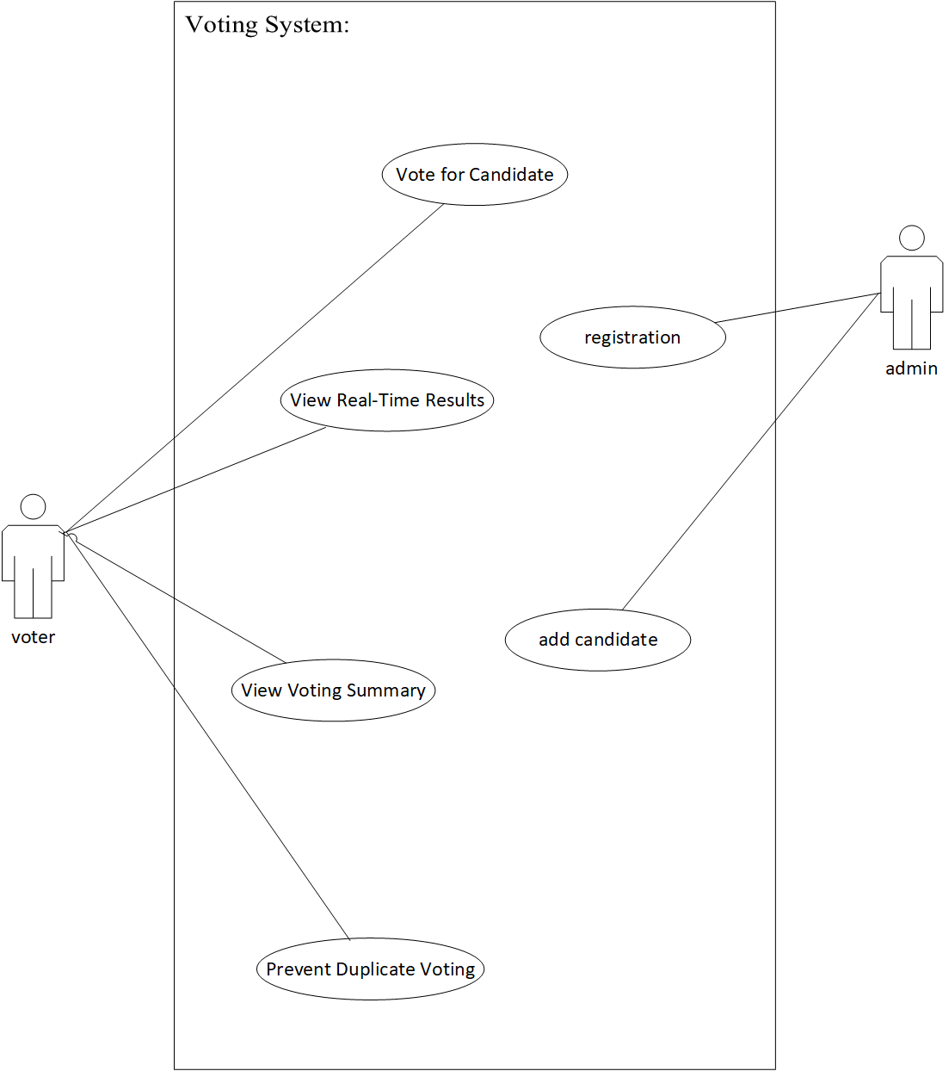
Object diagram

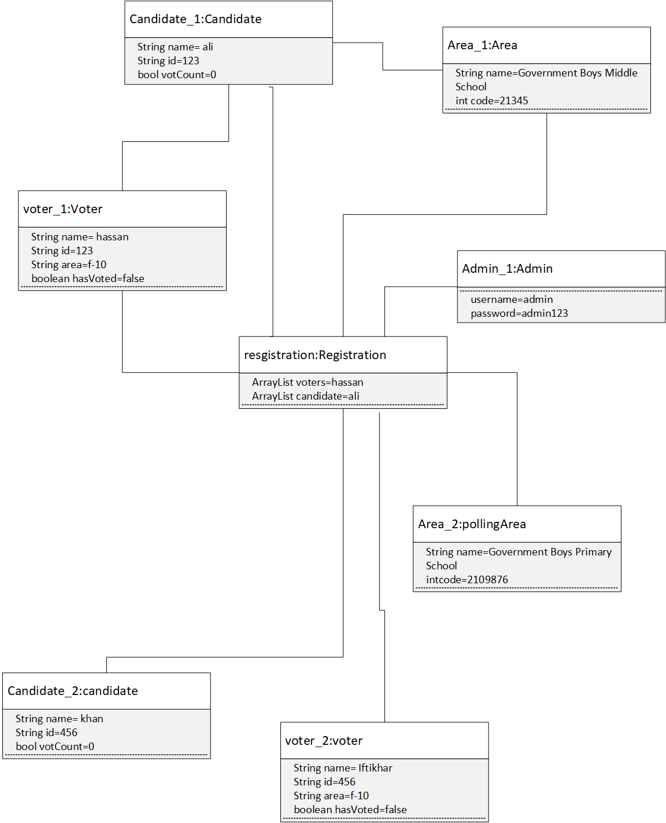

Sequence diagram

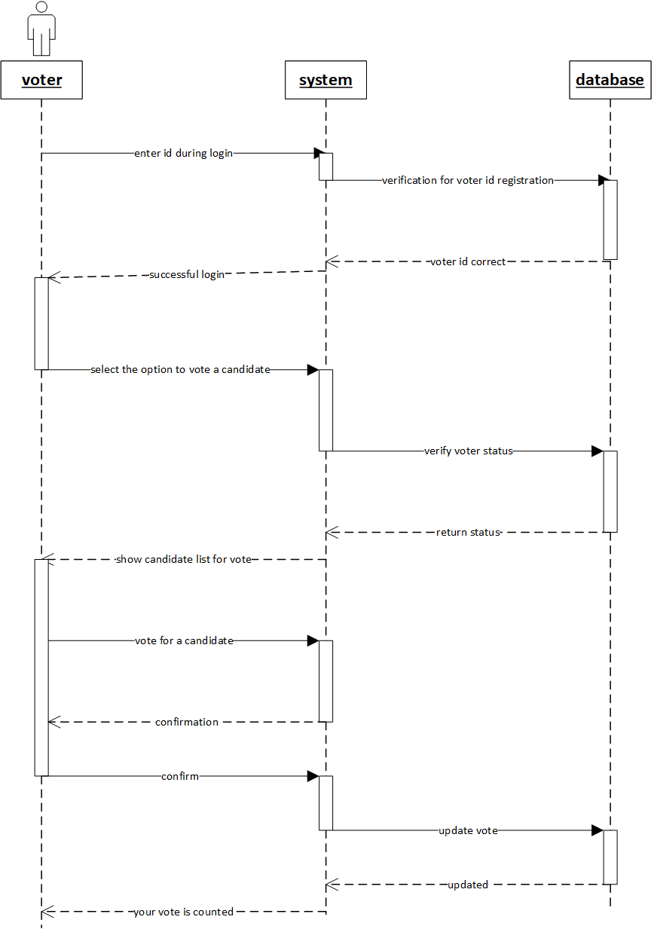

Communication diagram
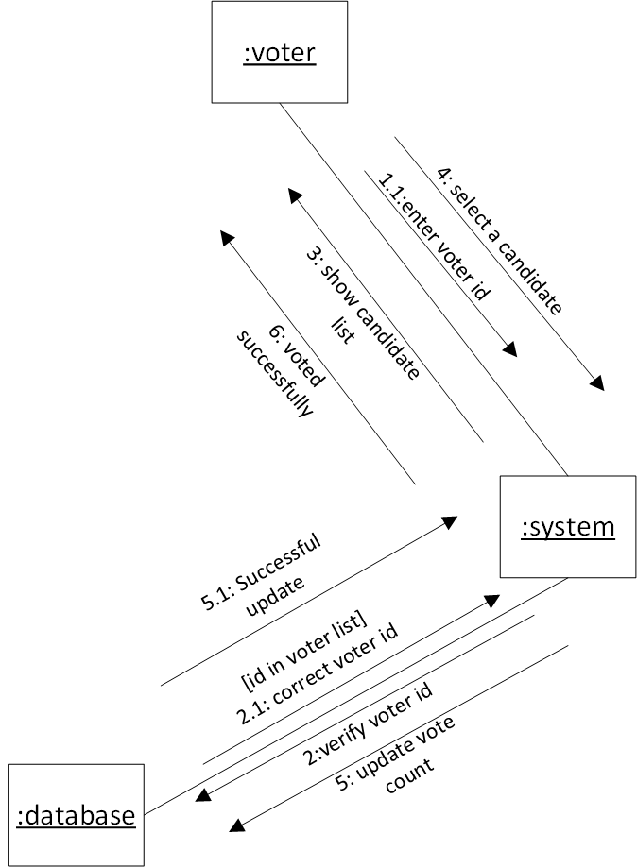

Petri-Nets
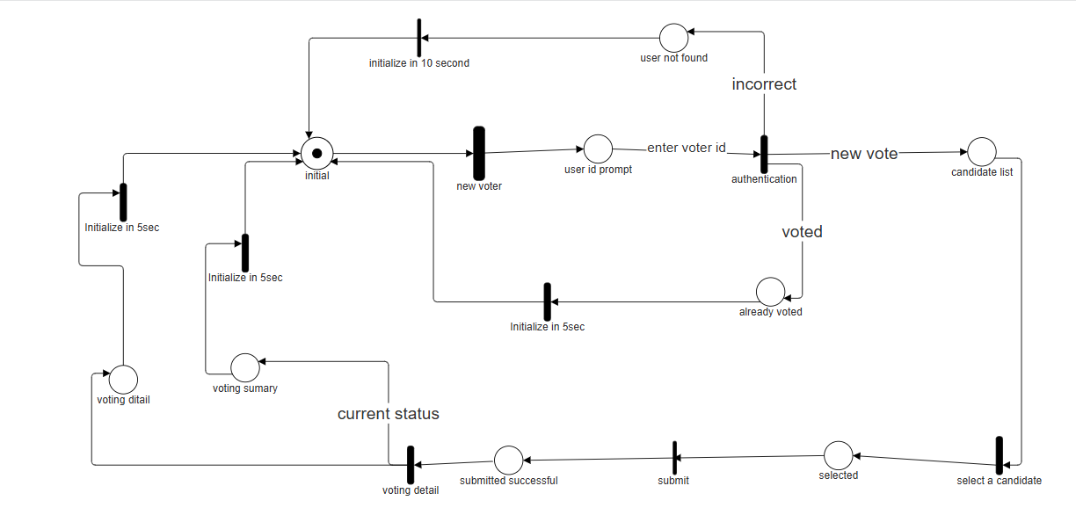

Timing Diagram
